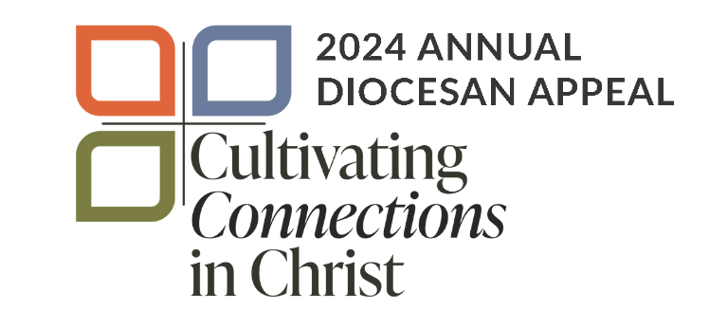

Transmittal Report

Date: __________________________
Parish number: __________________
Parish name: ____________________
City/Town: _____________________
Name of person completing this form:
________________________________________
Daytime phone number: ___________________
Email ___________________________________

 | This Report | Total to Date  (not required by Diocese,  for parish records only)
1. Total number of cards enclosed
2. Total amount of pledges and one-time gifts | $ | $
3. Total number of checks enclosed |  | $

Explanation:
Line #1 – Total number of donation cards enclosed.
Line #2 – Total dollar amount of all pledges AND one-time gifts enclosed.
Line #3 – Total number of checks enclosed.
The Total to Date column may be used for your parish records. It is not required by the finance office. The Weekly Pledge Journal e-mailed to you will reflect the ongoing total.

Steps to Success:
- Please Do NOT send cash – please issue a parish check for any cash gifts.
- Please Do NOT have donors write credit card numbers on pledge cards. Instead, direct them to dmdiocese.org/giving or have them call the Stewardship Department at 515-237-5083.
- Please place enough postage on your ADA envelopes before mailing so it arrives to the Finance Department in a timely and safe manner.
- Using the transmittal envelopes provided by the Diocese, please mail this weekly transmittal form, signed and completed pledge cards, personal checks and a parish check for any cash gifts to the diocesan finance office.
Diocese of Des Moines
Office of Finance
601 Grand Avenue
Des Moines, Iowa 50309
(515) 237-5028
rwaskel@dmdiocese.org

